<https://engineeringinterviewquestions.com/embedded-systems-viva-questions-and-answers-ece/>

Arm Mbed LPC1768

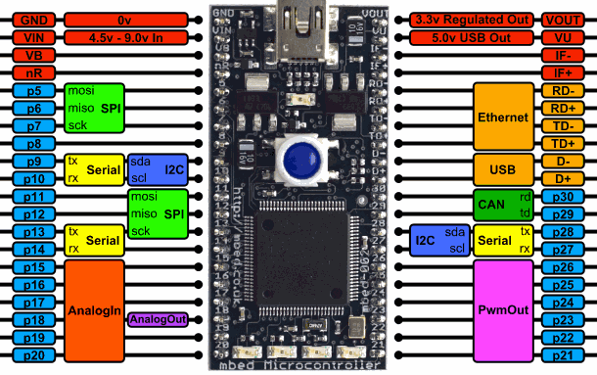

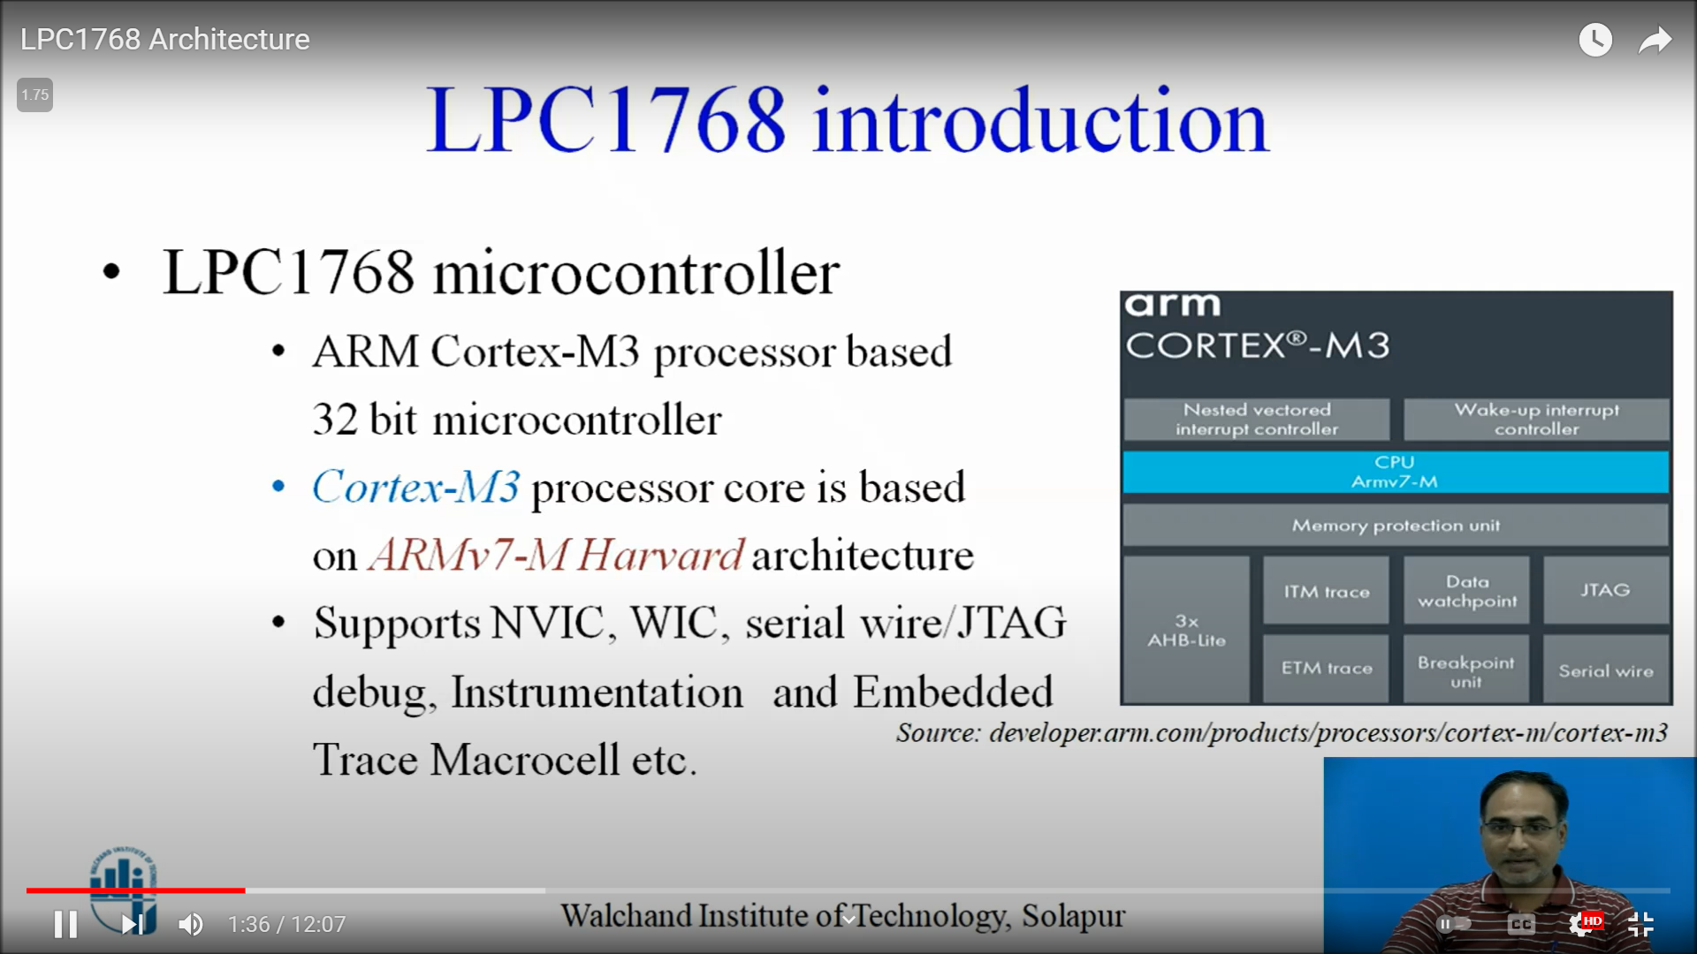

Arm v 7 M -> microcontroller, A -> application, R -> realtime

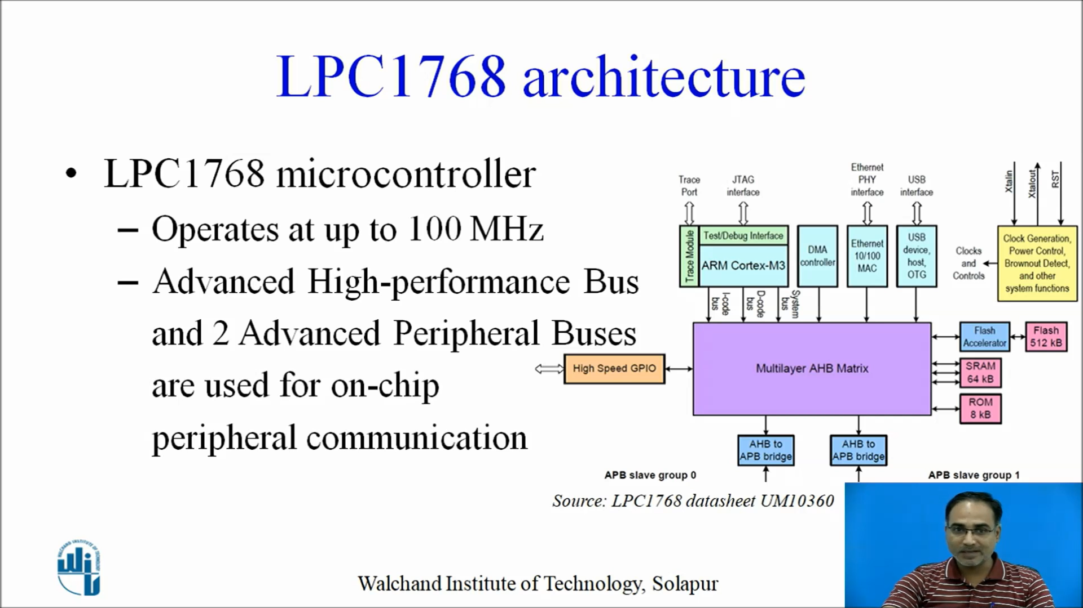

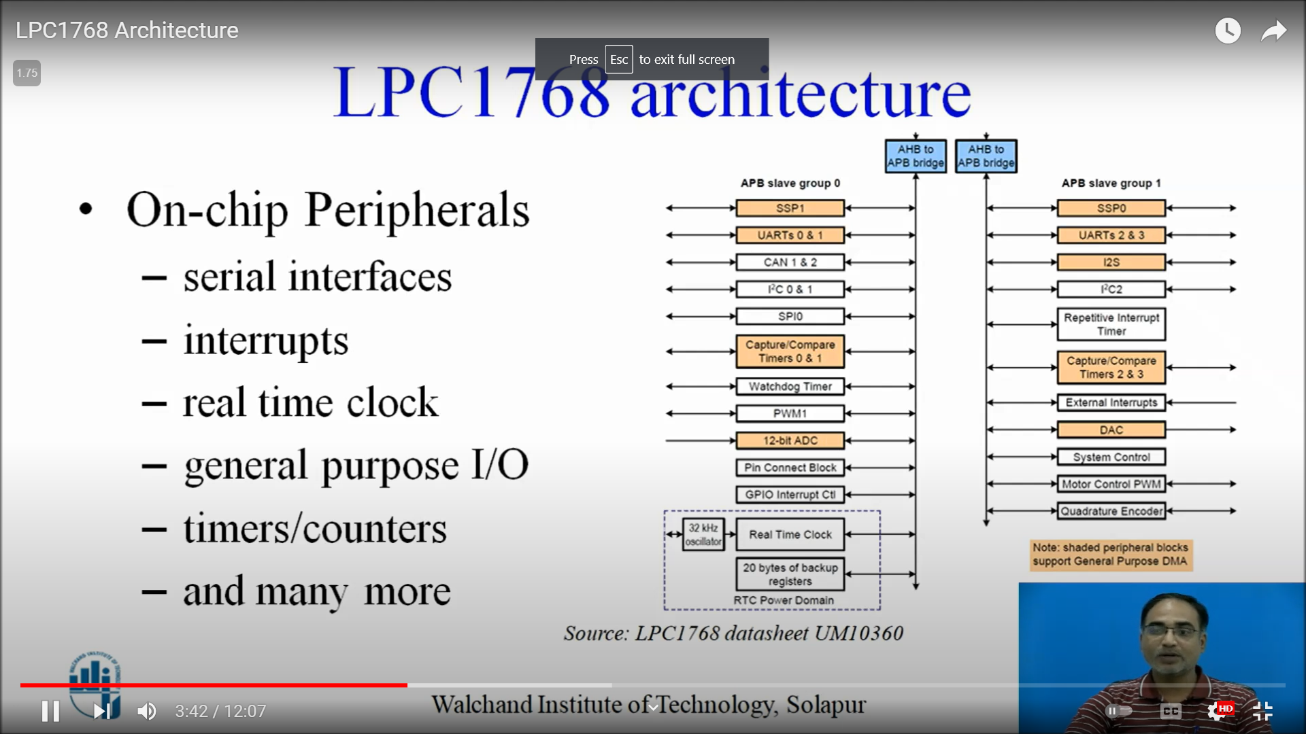

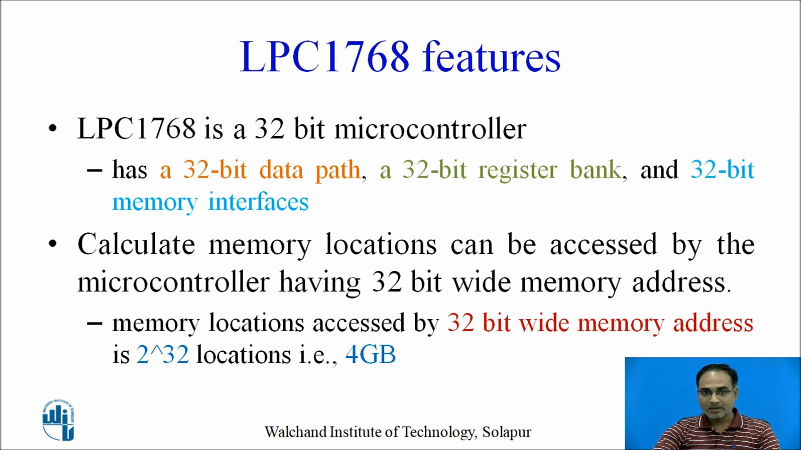

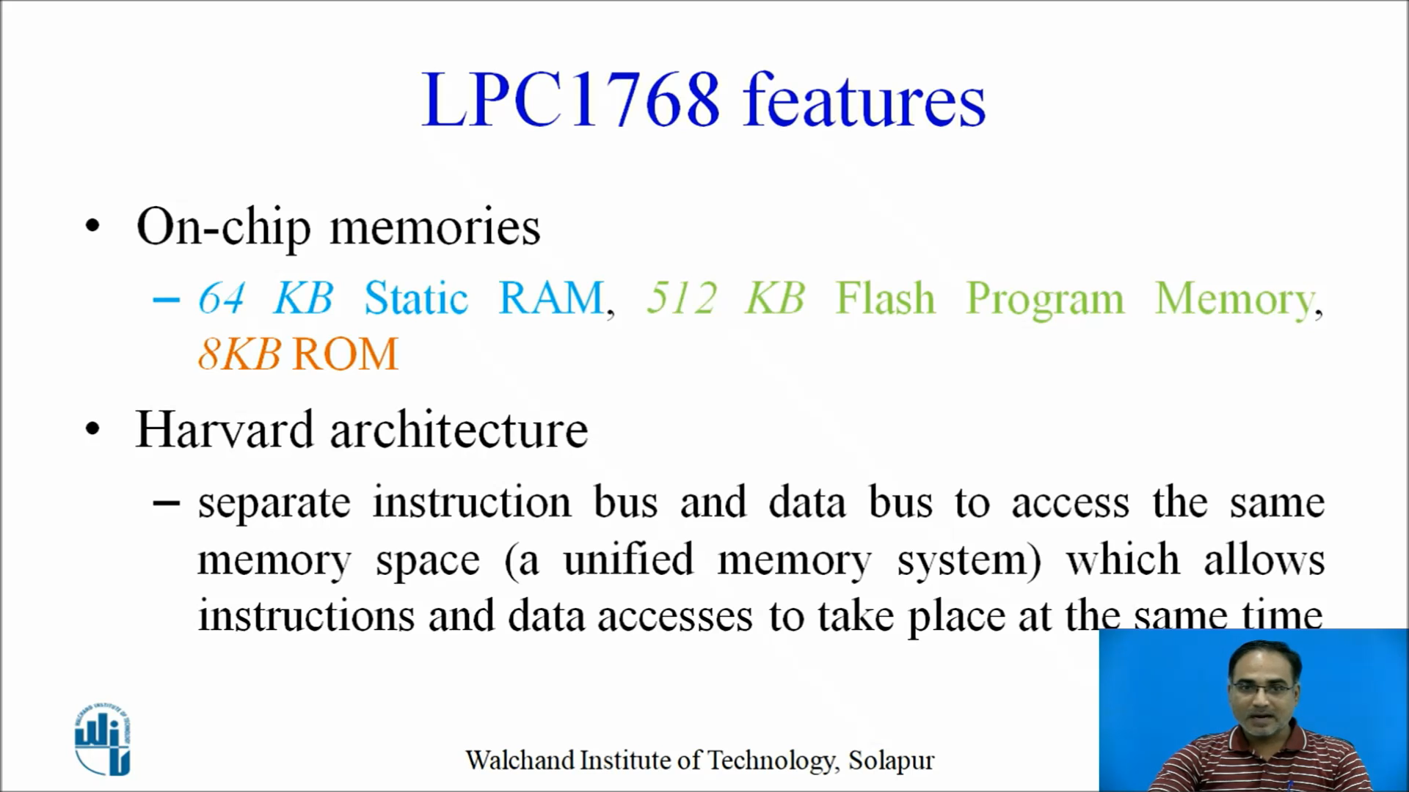

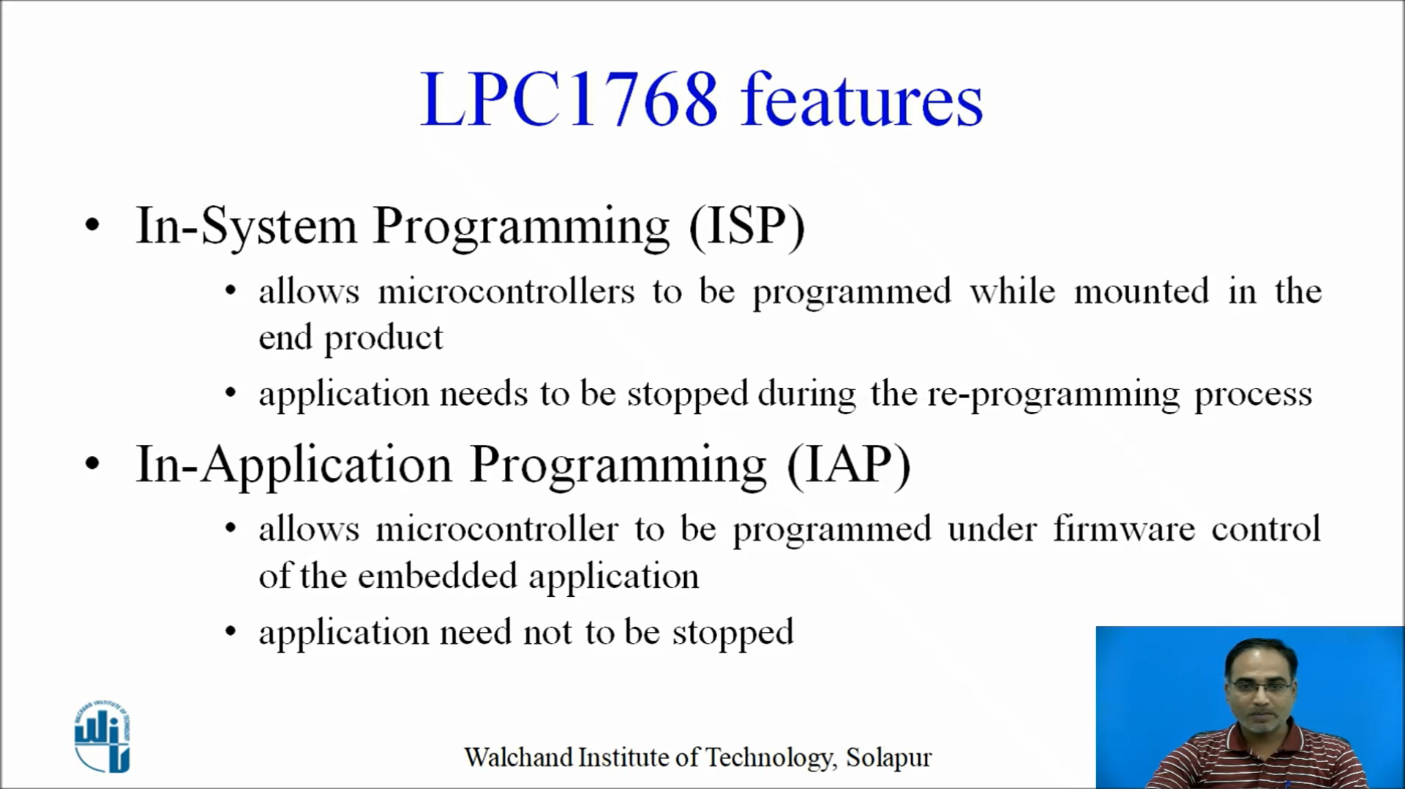

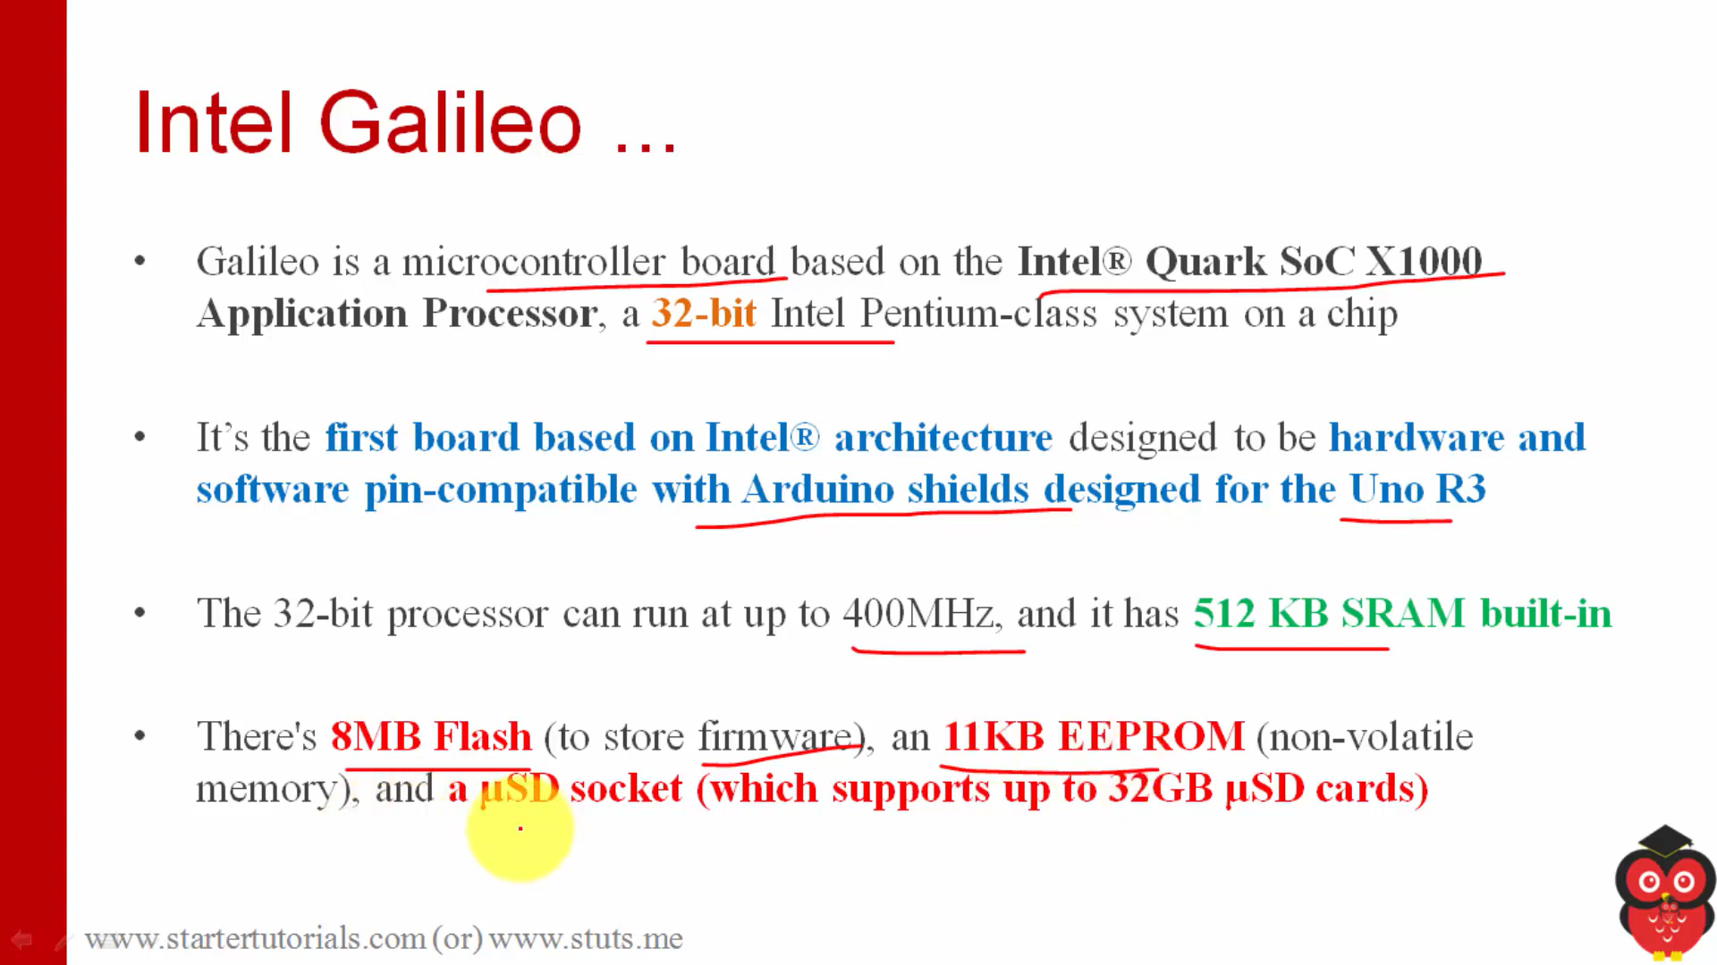

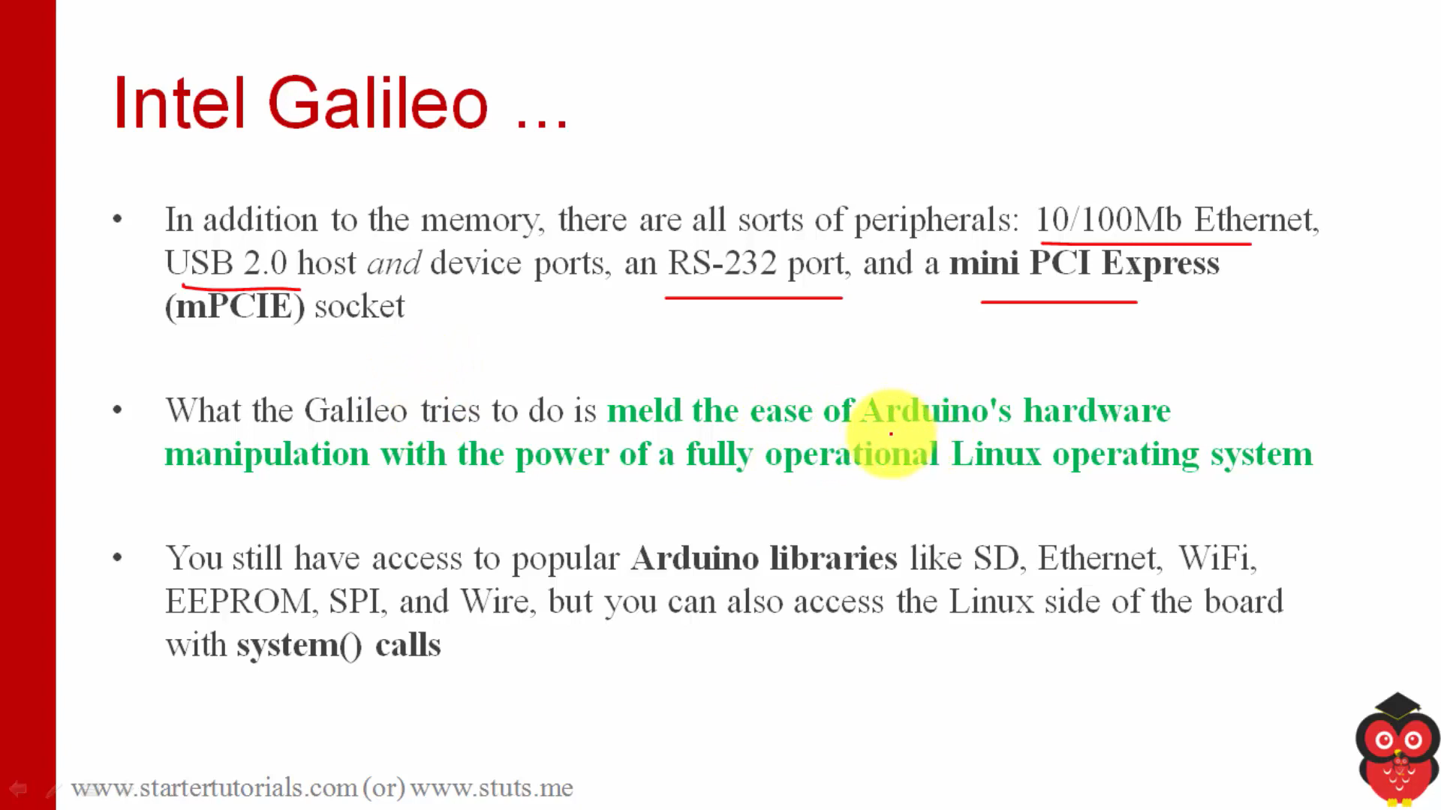

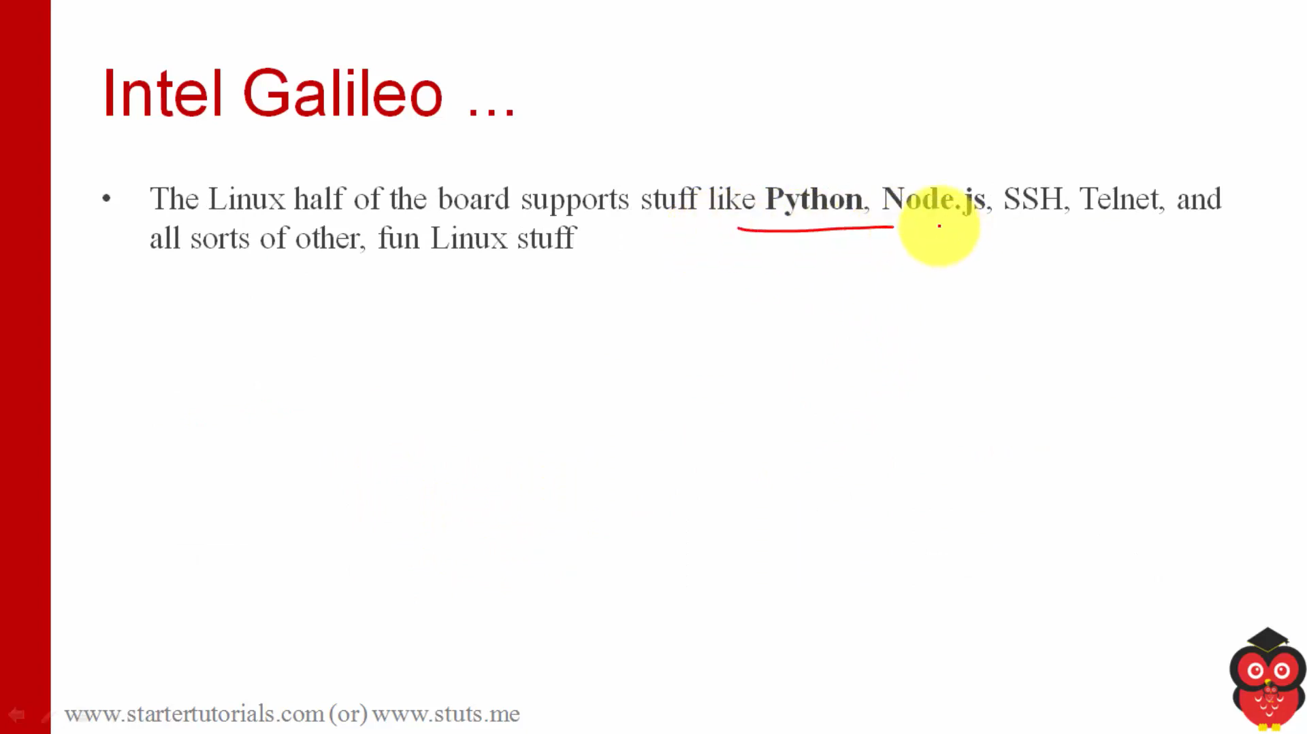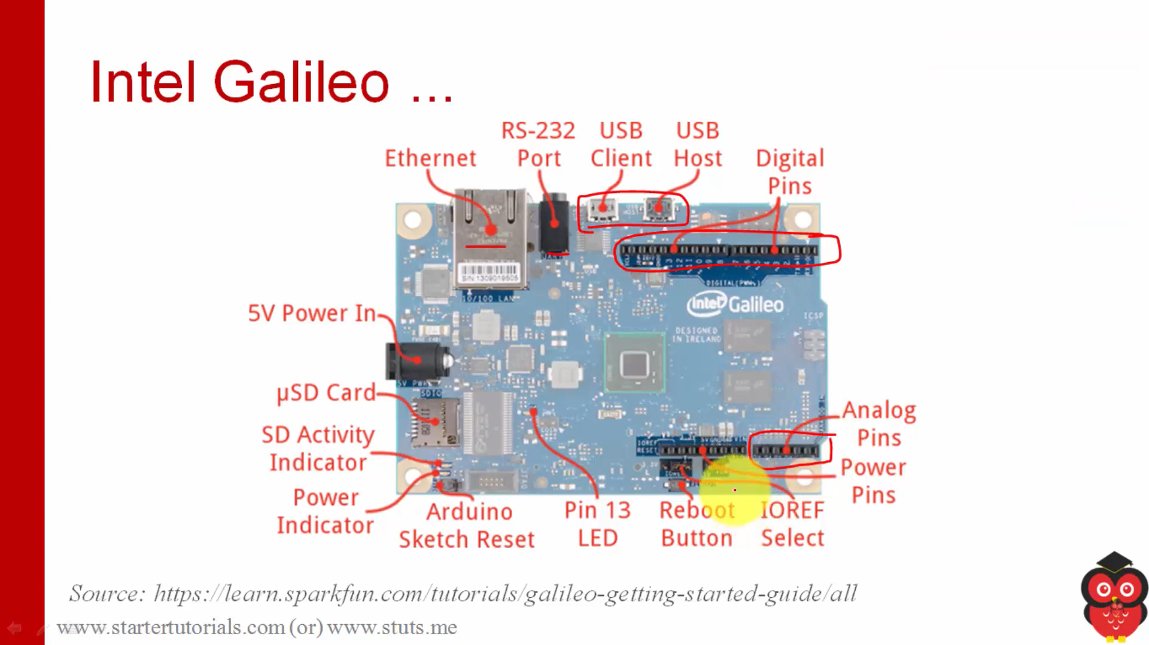

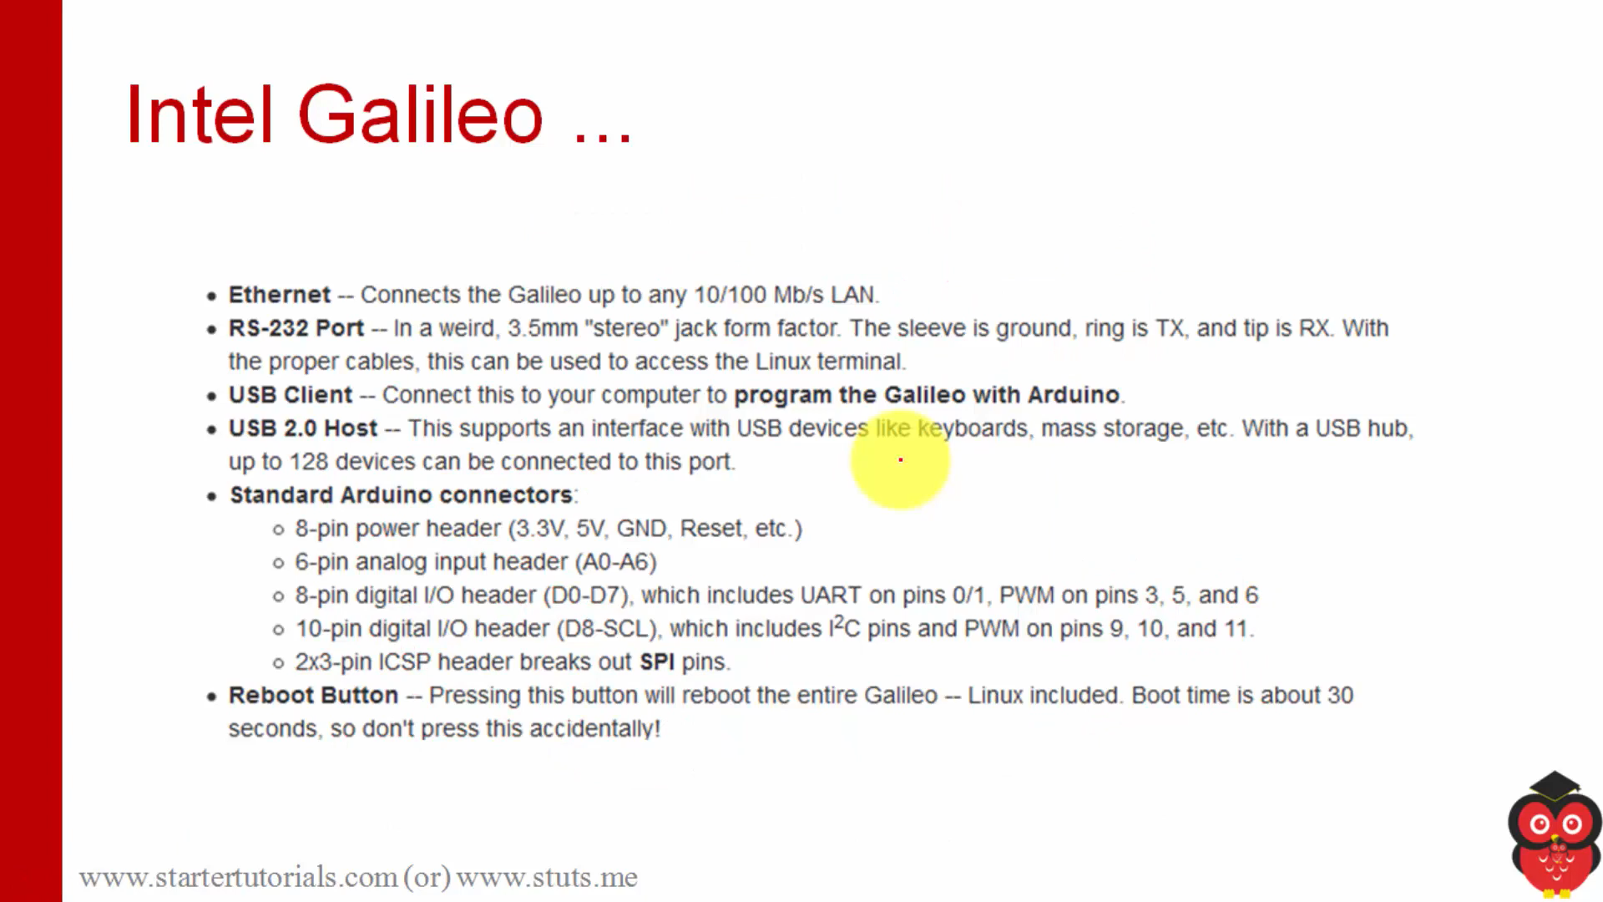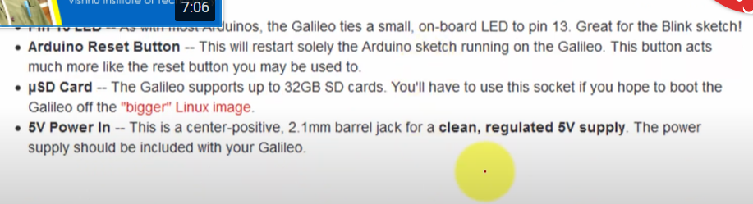

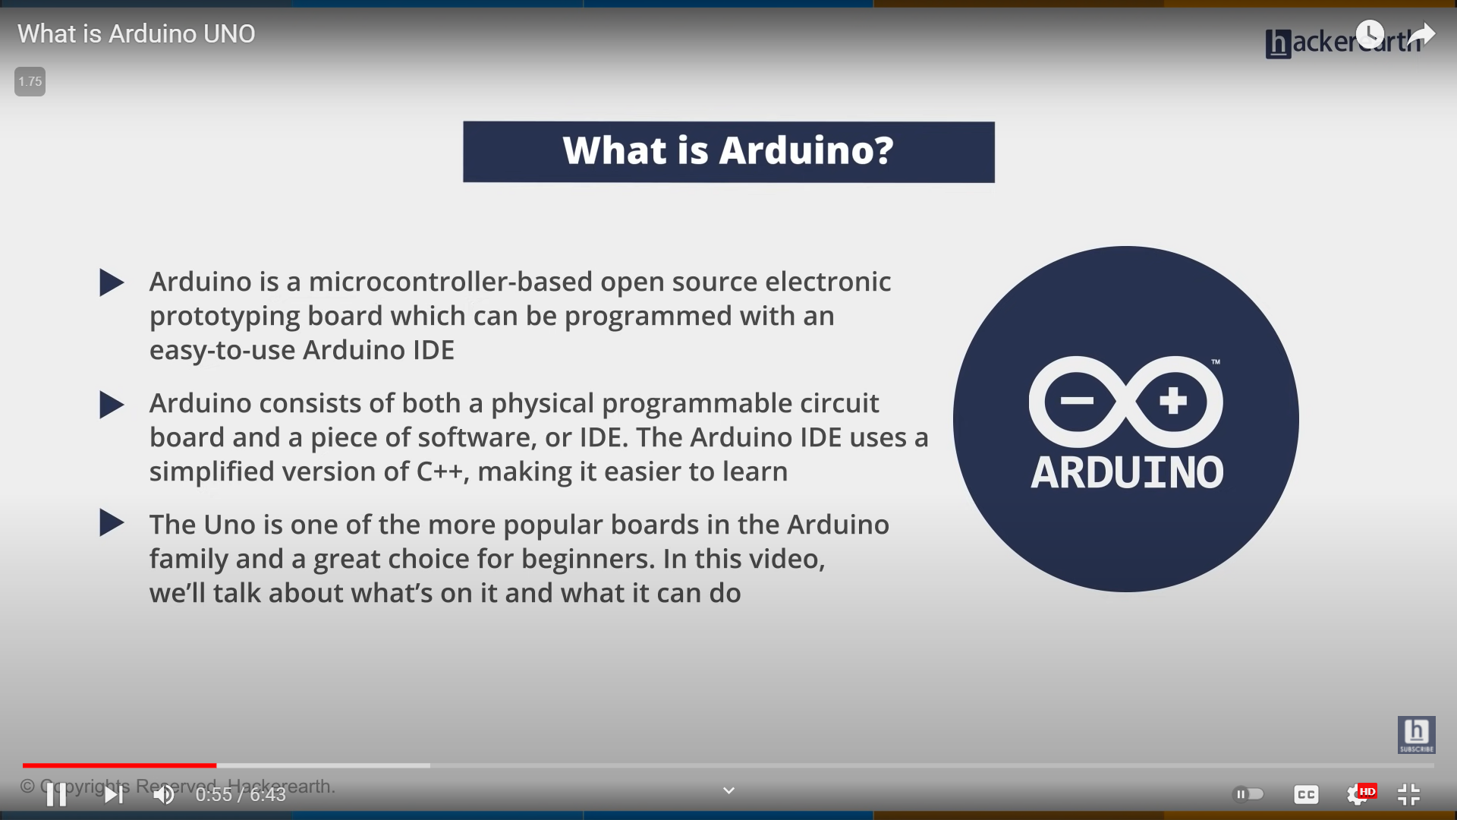

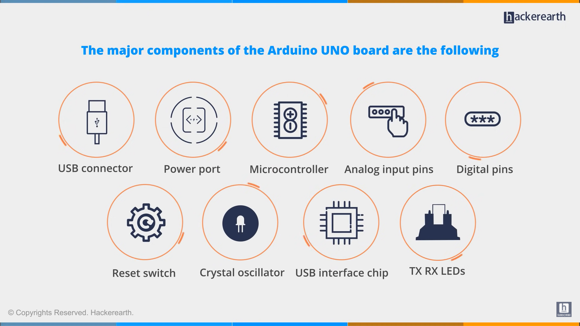

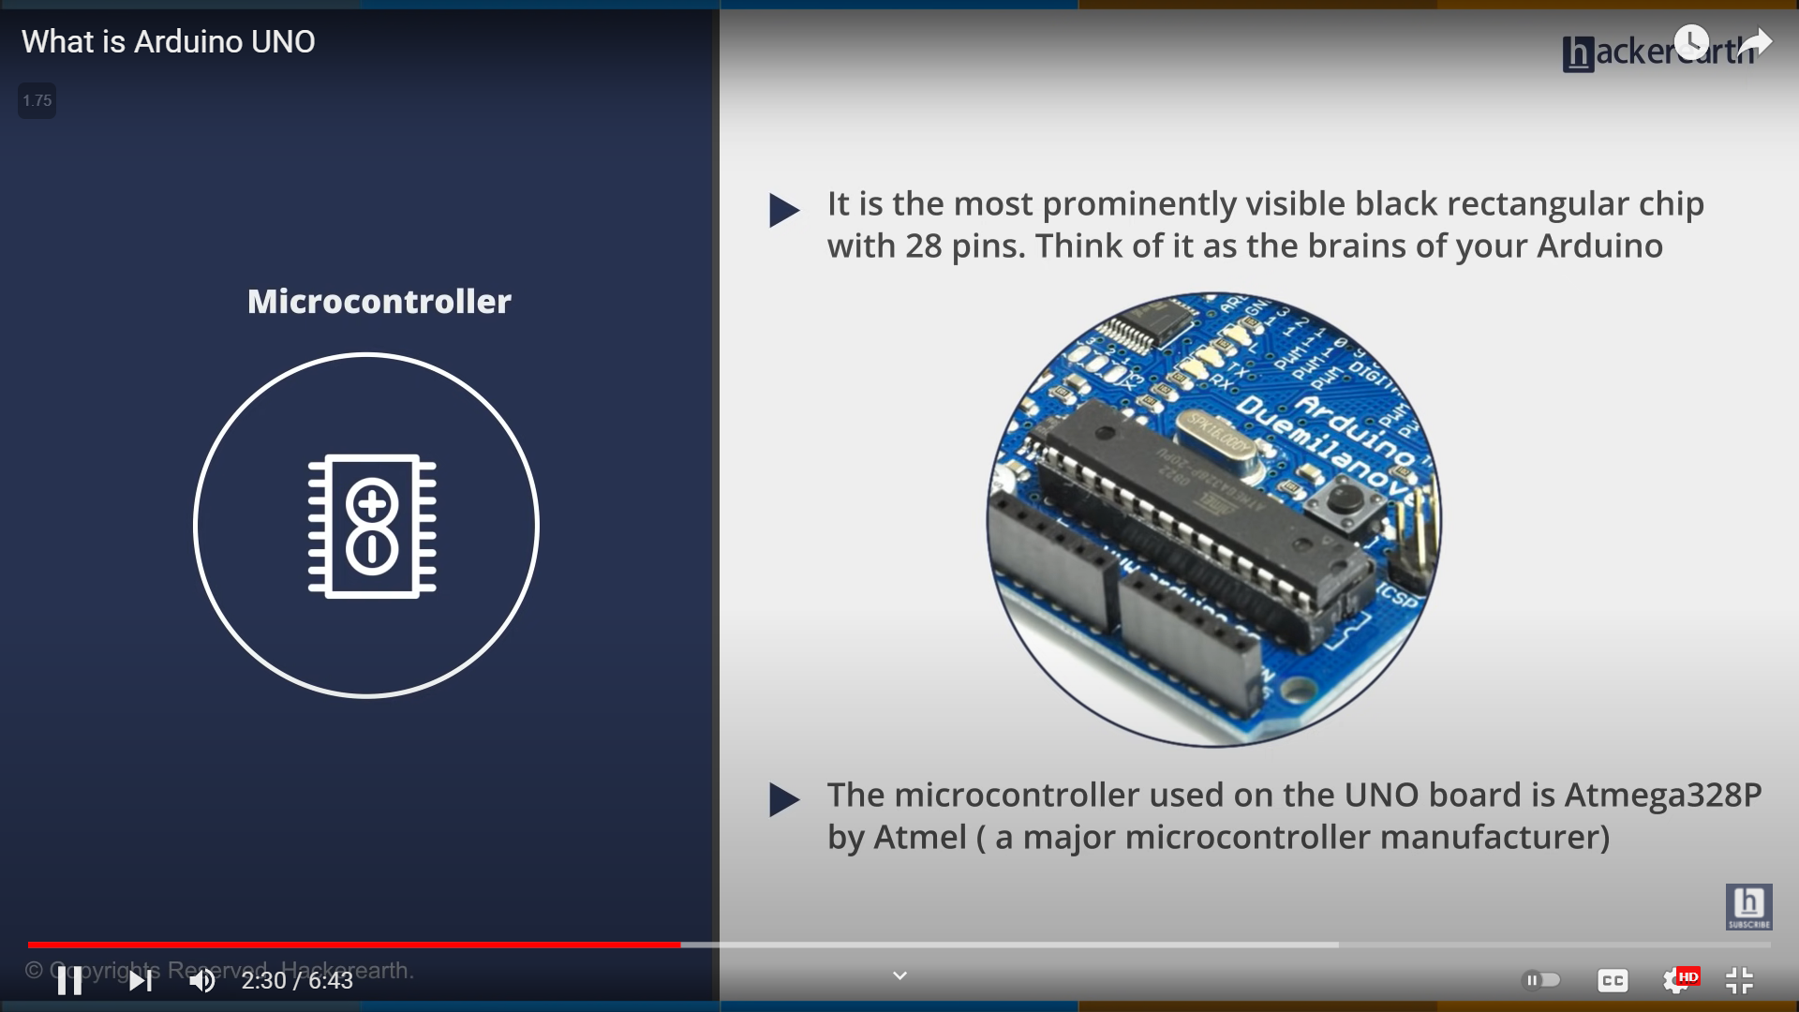

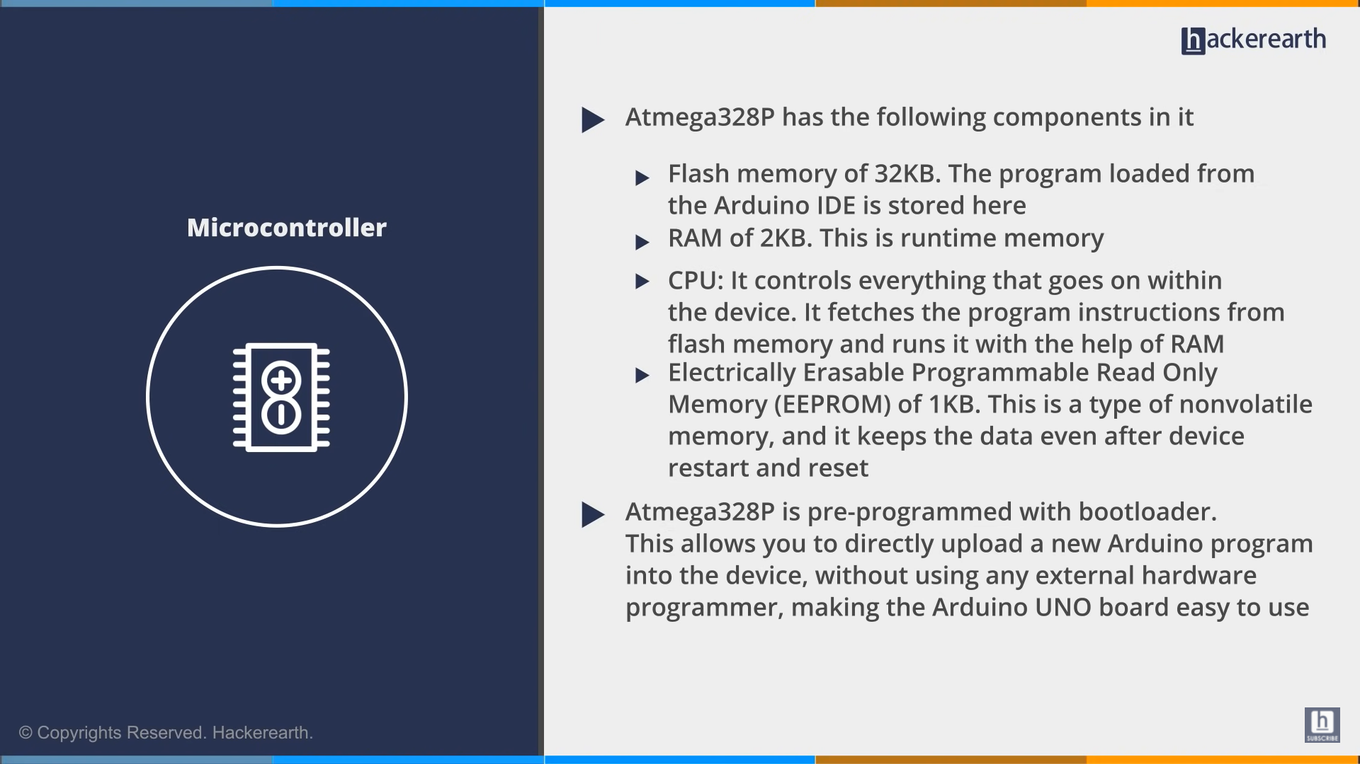

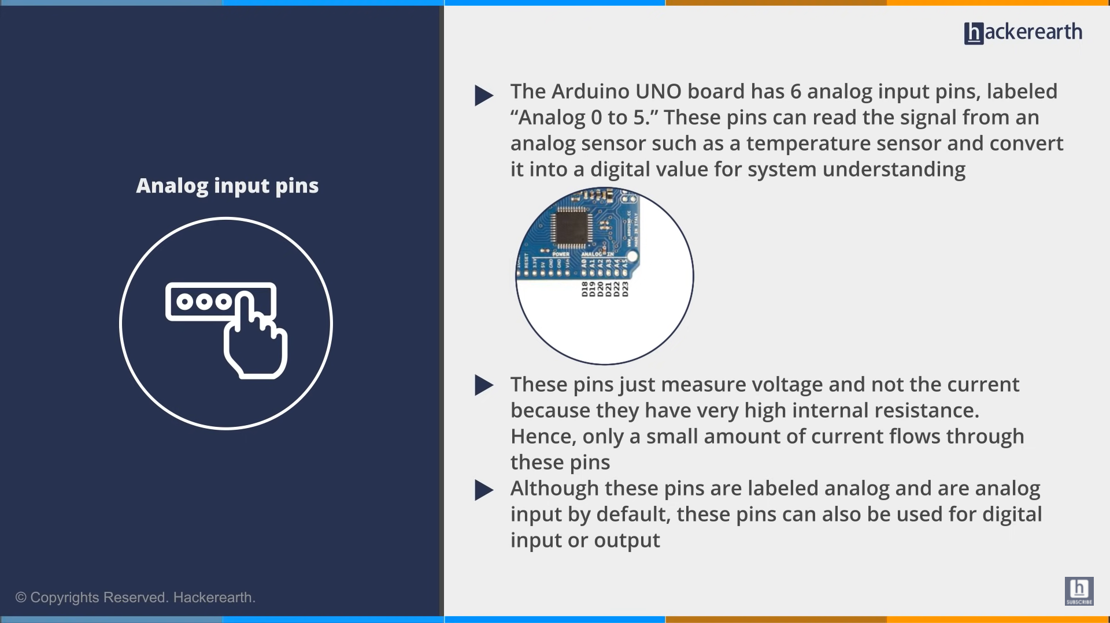

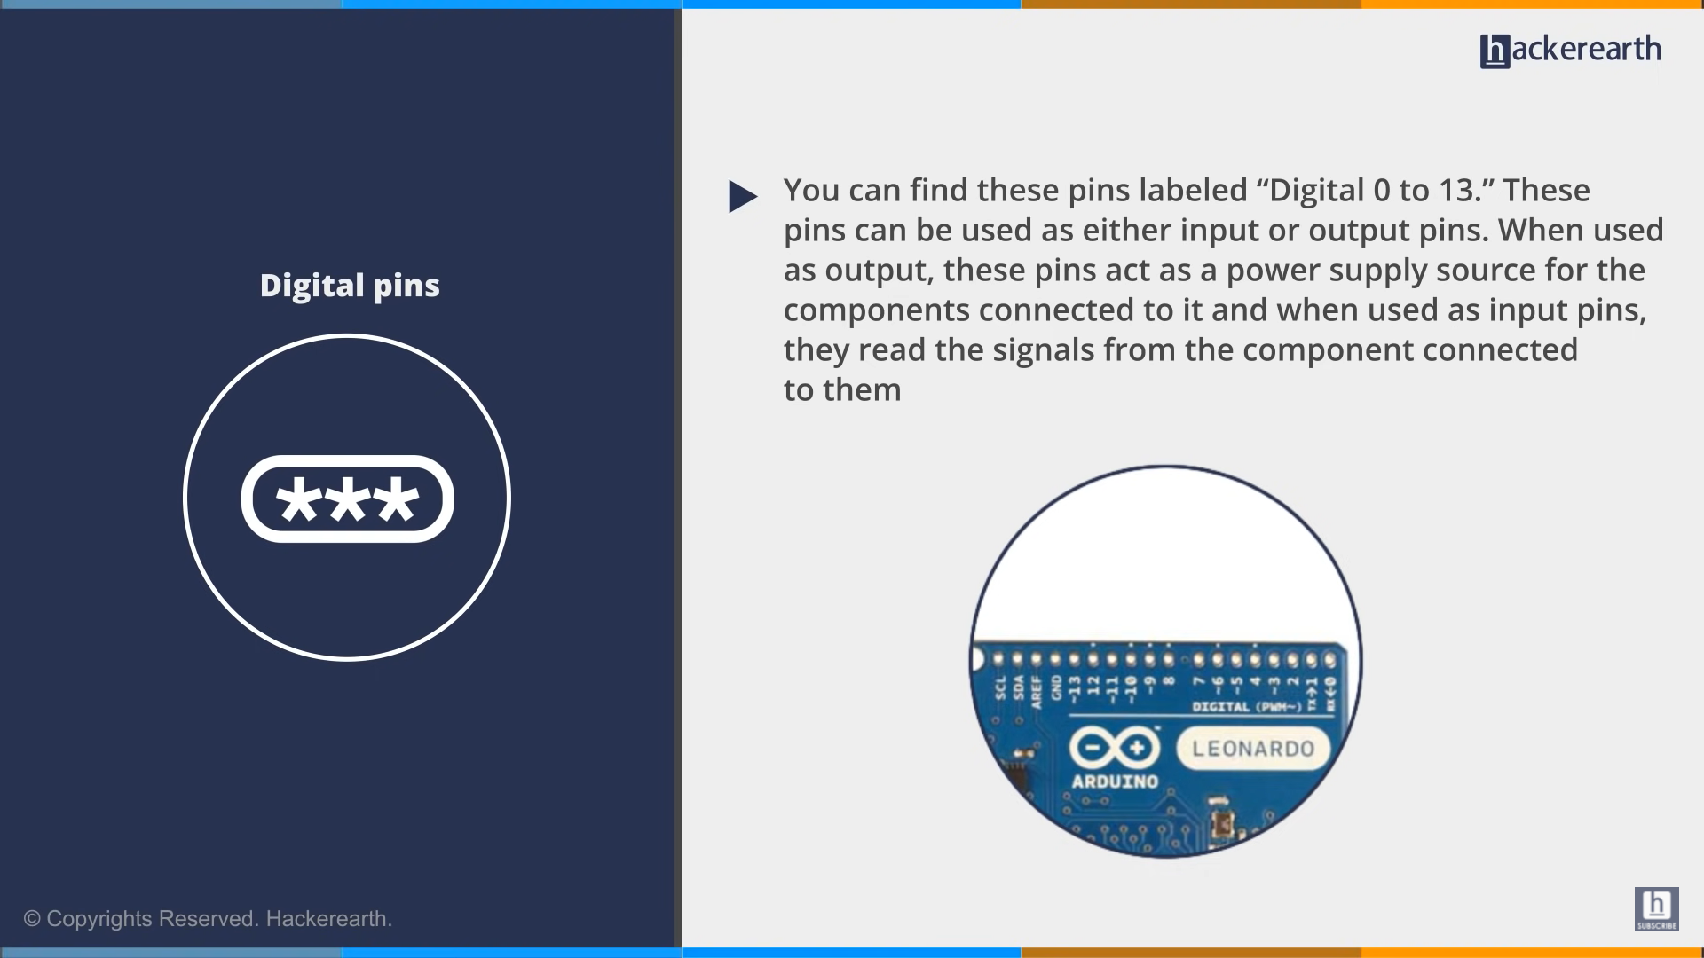

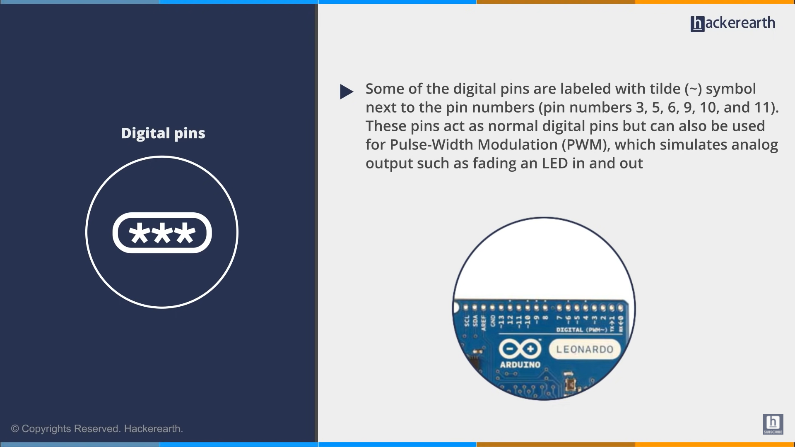

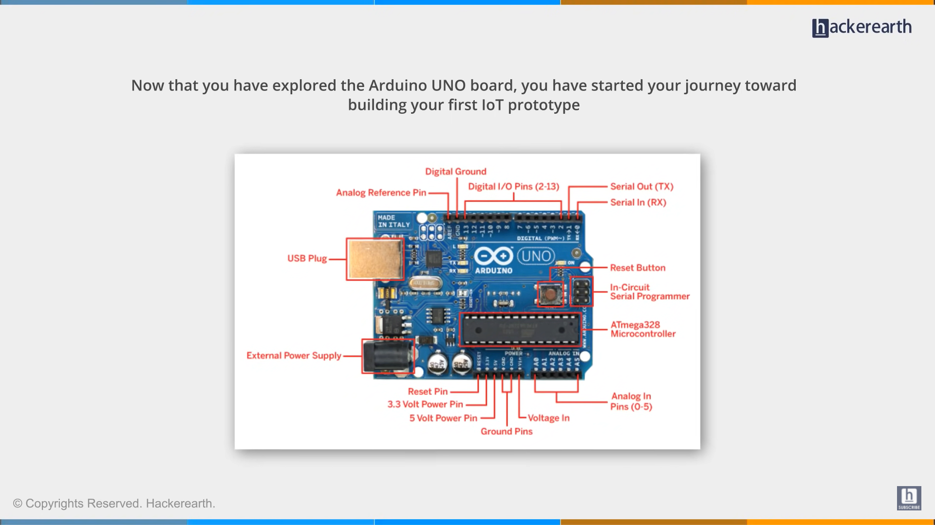

* InterruptIn interface to trigger an event when a digital input pin changes. You can trigger interrupts on the rising edge (change from 0 to 1) or falling edge (change from 1 to 0) of signals.

* Use the AnalogIn API to read an external voltage applied to an analog input pin. AnalogIn() reads the voltage as a fraction of the system voltage

Use the BusOut interface to combine a number of DigitalOut pins to write them at once. This API is useful for writing to multiple pins together as single interface instead of individual pins

Use the DigitalOut interface to configure and control a digital output pin by setting the pin to logic level 0 or 1.

* https://www.avnet.com/wps/portal/abacus/resources/article/pir-and-ultrasonic-sensors-whats-the-difference-and-how-do-they-work/#:~:text=PIR%20sensors%20can%20be%20used,or%20more%20people%20are%20present.

* There are two primary technologies used in detecting the presence of people, pyro-electric / passive infra-red (PIR) and ultrasonic. Both work quite differently and have different benefits, depending on the application.

All objects with a temperature above absolute zero emit heat energy in the form of radiation – this is known as Wien’s Law. PIR sensors work on the basis of detecting changes in this infrared (IR) radiation thereby detecting the presence of a human – or any other warm, moving object.

* An alternative approach is to use ultrasonic transducers to detect people present within a building. This uses sound waves at a frequency higher than humans are able to hear – typically in the range 30kHz to 10MHz. Transducers comprise a pair of devices, one is a transmitter and one is a receiver

* What is mutex in embedded system?

Mutex (Wikipedia) In computer science, a lock or mutex (from mutual exclusion) is a synchronization mechanism for enforcing limits on access to a resource in an environment where there are many threads of execution. A lock is designed to enforce a mutual exclusion concurrency control policy.

* WHAT semaphore

a semaphore is a variable or abstract data type used to control access to a common resource by multiple threads and avoid critical section problems in a concurrent system such as a multitasking operating system. Semaphores are a type of synchronization primitives.

* What is Digital Signal Controller?

It is a single chip microcomputer with a Digital Signal Processing as core unit. These microcontrollers have limited processing power. It is a hybrid of microcontroller and DSPs.

* Use the Ticker interface to set up a recurring interrupt; it calls a function repeatedly and at a specified rate.

You can create any number of Ticker objects, allowing multiple outstanding interrupts at the same time. The function can be a static function, a member function of a particular object or a Callback object

* .read() is used to reaad counters

* An ultrasonic sensor is an electronic device that measures the distance of a target object by emitting ultrasonic sound waves, and converts the reflected sound into an electrical signal. Ultrasonic waves travel faster than the speed of audible sound (i.e. the sound that humans can hear). Ultrasonic sensors have two main components: the transmitter (which emits the sound using piezoelectric crystals) and the receiver (which encounters the sound after it has travelled to and from the target).

* A sensor is a device that produces an output signal for the purpose of sensing of a physical phenomenon

* https://www.geeksforgeeks.org/what-happens-when-we-turn-on-computer/#:~:text=The%20first%20thing%20a%20computer,of%20controlling%20the%20computer's%20hardware.

* https://www.quora.com/What-is-the-difference-between-an-IR-detector-and-a-UV-V-detector

* https://whatis.techtarget.com/definition/instruction

* Stands for "Interrupt Service Routine." An ISR (also called an interrupt handler) is a software process invoked by an interrupt request from a hardware device. It handles the request and sends it to the CPU, interrupting the active process. When the ISR is complete, the process is resumed.

* PRINTF

* Use the PwmOut interface to control the frequency and duty cycle of a PWM signal

* pulse with modulation

* digitalOut()

Write a HIGH or a LOW value to a digital pin.

If the pin has been configured as an OUTPUT with pinMode(), its voltage will be set to the corresponding value: 5V (or 3.3V on 3.3V boards) for HIGH, 0V (ground) for LOW.

If the pin is configured as an INPUT, digitalWrite() will enable (HIGH) or disable (LOW) the internal pullup on the input pin. It is recommended to set the pinMode() to INPUT_PULLUP to enable the internal pull-up resistor. See the digital pins tutorial for more information

* To measure the distance the sound has travelled we use the formula: Distance = (Time x SpeedOfSound) / 2. The "2" is in the formula because the sound has to travel back and forth. First the sound travels away from the sensor, and then it bounces off of a surface and returns back.

* CISC vs RICS

The CISC approach attempts to minimize the number of instructions per program, sacrificing the number of cycles per instruction. RISC does the opposite, reducing the cycles per instruction at the cost of the number of instructions per program.

* An instruction set is a group of commands for a CPU in machine language. The term can refer to all possible instructions for a CPU or a subset of instructions to enhance its performance in certain situations.

* Bid rat baud rate

* memory leak

A memory leak occurs when memory is allocated and not freed after use, or when the pointer to a memory allocation is deleted, rendering the memory no longer usable. Memory leaks degrade performance due to increased paging, and over time, cause a program to run out of memory and crash

* Components of embedd